Assignment 17
Academic Data Insights
SQL Views and Common Table Expressions (CTEs)
Recorded verification results

Students | 60 records
Courses | 30 records
Enrolments | 108 records
Modified CourseSummary | 30 courses / 108 enrolments
InstructorSchedule, Spring 2024 | 136 rows
EligibleGraduates | 21 students; GPA 3.7–3.9
SemesterCourses CTE | 27 courses in Spring 2024

Q1: CREATE UNIVERSITY TABLES
--A. Students table
CREATE TABLE Students (
StudentID INTEGER PRIMARY KEY,
FirstName TEXT NOT NULL,
LastName TEXT NOT NULL,
DOB TEXT,
Major TEXT,
GPA REAL
);
--B. Courses table
CREATE TABLE Courses (
CourseID INTEGER PRIMARY KEY,
CourseName TEXT NOT NULL,
Department TEXT
);
--C. Instructors table
CREATE TABLE Instructors (
InstructorID INTEGER PRIMARY KEY,
InstructorName TEXT NOT NULL,
Department TEXT
);
--D. Enrolments table
CREATE TABLE Enrolments (
EnrollmentID INTEGER PRIMARY KEY,
StudentID INTEGER,
CourseID INTEGER,
Semester TEXT,
Grade TEXT,
FOREIGN KEY (StudentID)
REFERENCES Students(StudentID),
FOREIGN KEY (CourseID)
REFERENCES Courses(CourseID)
);
SELECT name
FROM sqlite_master
WHERE type = 'table'
ORDER BY name;

Q.2: INSERT STUDENT RECORDS
-- A. will start with the first 5 students
INSERT INTO Students
(StudentID, FirstName, LastName, DOB, Major, GPA)
VALUES
(1, 'Alex', 'Smith', '2000-01-01', 'Computer Science', 3.5),
(2, 'Bella', 'Johnson', '2000-02-02', 'Business', 3.6),
(3, 'Charlie', 'Brown', '2000-03-03', 'Physics', 3.7),
(4, 'Diana', 'Davis', '2000-04-04', 'Mathematics', 3.8),
(5, 'Ethan', 'Miller', '2000-05-05', 'Biology', 3.9);

-- To verify the first five student records
SELECT *
FROM Students
ORDER BY StudentID;

SCREENSHOT A Students 60 Records.png
Students table verification
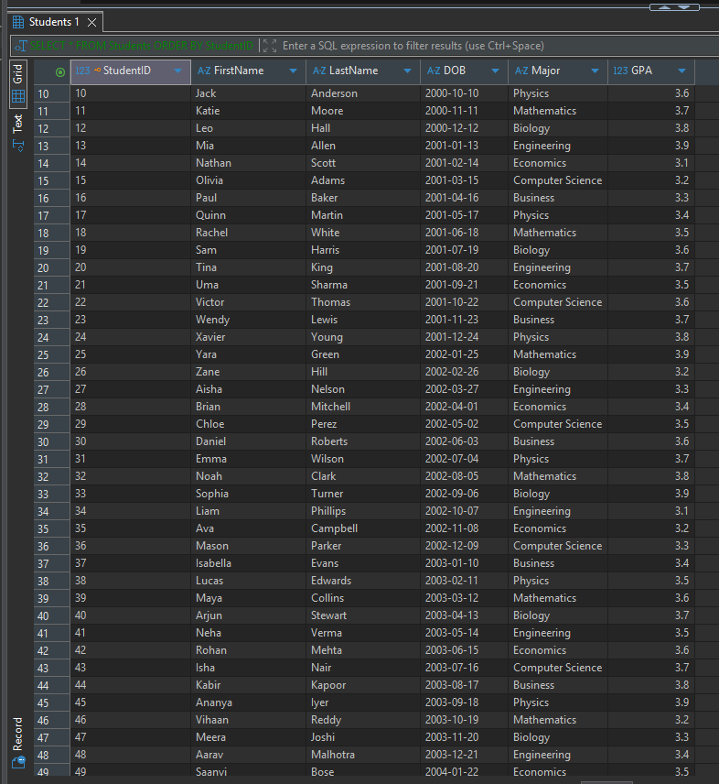

-- B. INSERT REMAINING STUDENTS (6–60)
INSERT INTO Students
(StudentID, FirstName, LastName, DOB, Major, GPA)
VALUES
(6, 'Frank', 'Taylor', '2000-06-06', 'Engineering', 3.2),
(7, 'Grace', 'Lee', '2000-07-07', 'Economics', 3.3),
(8, 'Hannah', 'Walker', '2000-08-08', 'Computer Science', 3.4),
(9, 'Isaac', 'Carter', '2000-09-09', 'Business', 3.5),
(10, 'Jack', 'Anderson', '2000-10-10', 'Physics', 3.6),
(11, 'Katie', 'Moore', '2000-11-11', 'Mathematics', 3.7),
(12, 'Leo', 'Hall', '2000-12-12', 'Biology', 3.8),
(13, 'Mia', 'Allen', '2001-01-13', 'Engineering', 3.9),
(14, 'Nathan', 'Scott', '2001-02-14', 'Economics', 3.1),
(15, 'Olivia', 'Adams', '2001-03-15', 'Computer Science', 3.2),
(16, 'Paul', 'Baker', '2001-04-16', 'Business', 3.3),
(17, 'Quinn', 'Martin', '2001-05-17', 'Physics', 3.4),
(18, 'Rachel', 'White', '2001-06-18', 'Mathematics', 3.5),
(19, 'Sam', 'Harris', '2001-07-19', 'Biology', 3.6),
(20, 'Tina', 'King', '2001-08-20', 'Engineering', 3.7),
(21, 'Uma', 'Sharma', '2001-09-21', 'Economics', 3.5),
(22, 'Victor', 'Thomas', '2001-10-22', 'Computer Science', 3.6),
(23, 'Wendy', 'Lewis', '2001-11-23', 'Business', 3.7),
(24, 'Xavier', 'Young', '2001-12-24', 'Physics', 3.8),
(25, 'Yara', 'Green', '2002-01-25', 'Mathematics', 3.9),
(26, 'Zane', 'Hill', '2002-02-26', 'Biology', 3.2),
(27, 'Aisha', 'Nelson', '2002-03-27', 'Engineering', 3.3),
(28, 'Brian', 'Mitchell', '2002-04-01', 'Economics', 3.4),
(29, 'Chloe', 'Perez', '2002-05-02', 'Computer Science', 3.5),
(30, 'Daniel', 'Roberts', '2002-06-03', 'Business', 3.6),
(31, 'Emma', 'Wilson', '2002-07-04', 'Physics', 3.7),
(32, 'Noah', 'Clark', '2002-08-05', 'Mathematics', 3.8),
(33, 'Sophia', 'Turner', '2002-09-06', 'Biology', 3.9),
(34, 'Liam', 'Phillips', '2002-10-07', 'Engineering', 3.1),
(35, 'Ava', 'Campbell', '2002-11-08', 'Economics', 3.2),
(36, 'Mason', 'Parker', '2002-12-09', 'Computer Science', 3.3),
(37, 'Isabella', 'Evans', '2003-01-10', 'Business', 3.4),
(38, 'Lucas', 'Edwards', '2003-02-11', 'Physics', 3.5),
(39, 'Maya', 'Collins', '2003-03-12', 'Mathematics', 3.6),
(40, 'Arjun', 'Stewart', '2003-04-13', 'Biology', 3.7),
(41, 'Neha', 'Verma', '2003-05-14', 'Engineering', 3.5),
(42, 'Rohan', 'Mehta', '2003-06-15', 'Economics', 3.6),
(43, 'Isha', 'Nair', '2003-07-16', 'Computer Science', 3.7),
(44, 'Kabir', 'Kapoor', '2003-08-17', 'Business', 3.8),
(45, 'Ananya', 'Iyer', '2003-09-18', 'Physics', 3.9),
(46, 'Vihaan', 'Reddy', '2003-10-19', 'Mathematics', 3.2),
(47, 'Meera', 'Joshi', '2003-11-20', 'Biology', 3.3),
(48, 'Aarav', 'Malhotra', '2003-12-21', 'Engineering', 3.4),
(49, 'Saanvi', 'Bose', '2004-01-22', 'Economics', 3.5),
(50, 'Reyansh', 'Saxena', '2004-02-23', 'Computer Science', 3.6),
(51, 'Nisha', 'Gupta', '2004-03-24', 'Business', 3.7),
(52, 'Karan', 'Khanna', '2004-04-25', 'Physics', 3.8),
(53, 'Pooja', 'Patel', '2004-05-26', 'Mathematics', 3.9),
(54, 'Rahul', 'Singh', '2004-06-27', 'Biology', 3.1),
(55, 'Sneha', 'Desai', '2004-07-01', 'Engineering', 3.2),
(56, 'Varun', 'Menon', '2004-08-02', 'Economics', 3.3),
(57, 'Riya', 'Rao', '2004-09-03', 'Computer Science', 3.4),
(58, 'Aditya', 'Bhat', '2004-10-04', 'Business', 3.5),
(59, 'Kavya', 'Chopra', '2004-11-05', 'Physics', 3.6),
(60, 'Dev', 'Jain', '2004-12-06', 'Mathematics', 3.7);

-- To Verify that all 60 students were inserted
SELECT COUNT(*) AS TotalStudents
FROM Students;

-- Display all student records
SELECT *
FROM Students
ORDER BY StudentID;

Q.3: INSERT COURSES (101–130)
-- Q.3: INSERT COURSES (101–130)
INSERT INTO Courses
(CourseID, CourseName, Department)
VALUES
(101, 'Intro to CS', 'Computer Science'),
(102, 'Microeconomics', 'Economics'),
(103, 'General Physics', 'Physics'),
(104, 'Calculus I', 'Mathematics'),
(105, 'Biology 101', 'Biology'),
(106, 'Software Engineering', 'Computer Science'),
(107, 'Macroeconomics', 'Economics'),
(108, 'Thermodynamics', 'Physics'),
(109, 'Linear Algebra', 'Mathematics'),
(110, 'Genetics', 'Biology'),
(111, 'Database Systems', 'Computer Science'),
(112, 'Business Analytics', 'Business'),
(113, 'Quantum Physics', 'Physics'),
(114, 'Calculus II', 'Mathematics'),
(115, 'Microbiology', 'Biology'),
(116, 'Data Structures', 'Computer Science'),
(117, 'International Economics', 'Economics'),
(118, 'Electromagnetism', 'Physics'),
(119, 'Discrete Mathematics', 'Mathematics'),
(120, 'Ecology', 'Biology'),
(121, 'Machine Learning', 'Computer Science'),
(122, 'Financial Management', 'Business'),
(123, 'Classical Mechanics', 'Physics'),
(124, 'Statistics I', 'Mathematics'),
(125, 'Molecular Biology', 'Biology'),
(126, 'Computer Networks', 'Computer Science'),
(127, 'Econometrics', 'Economics'),
(128, 'Optics', 'Physics'),
(129, 'Probability Theory', 'Mathematics'),
(130, 'Biochemistry', 'Biology');
-- A. Verify course records
SELECT COUNT(*) AS TotalCourses
FROM Courses;
-- B. Display all courses
SELECT *
FROM Courses
ORDER BY CourseID;

SCREENSHOT B Courses 30 Records.png
Courses table verification
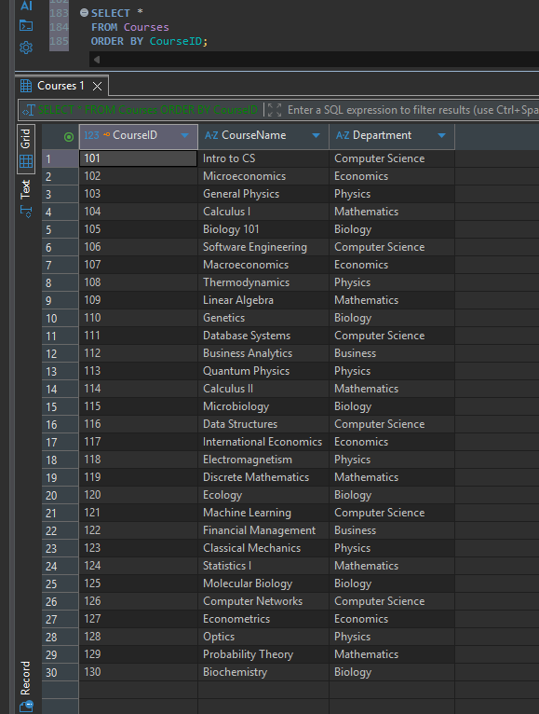
Q.4: INSERT INSTRUCTORS (201–230)
-- Q.4: INSERT INSTRUCTORS (201–230)
INSERT INTO Instructors
(InstructorID, InstructorName, Department)
VALUES
(201, 'Dr. Adams', 'Computer Science'),
(202, 'Dr. Baker', 'Economics'),
(203, 'Dr. Clark', 'Physics'),
(204, 'Dr. Davis', 'Mathematics'),
(205, 'Dr. Evans', 'Biology'),
(206, 'Dr. Foster', 'Engineering'),
(207, 'Dr. Grant', 'Business'),
(208, 'Dr. Hayes', 'Physics'),
(209, 'Dr. Irving', 'Mathematics'),
(210, 'Dr. Jenkins', 'Economics'),
(211, 'Dr. Kumar', 'Computer Science'),
(212, 'Dr. Lopez', 'Business'),
(213, 'Dr. Morgan', 'Physics'),
(214, 'Dr. Nelson', 'Mathematics'),
(215, 'Dr. Owens', 'Biology'),
(216, 'Dr. Patel', 'Computer Science'),
(217, 'Dr. Quinn', 'Economics'),
(218, 'Dr. Reed', 'Physics'),
(219, 'Dr. Shah', 'Mathematics'),
(220, 'Dr. Turner', 'Biology'),
(221, 'Dr. Verma', 'Computer Science'),
(222, 'Dr. Wilson', 'Business'),
(223, 'Dr. Xu', 'Physics'),
(224, 'Dr. Young', 'Mathematics'),
(225, 'Dr. Zhang', 'Biology'),
(226, 'Dr. Rao', 'Computer Science'),
(227, 'Dr. Sen', 'Economics'),
(228, 'Dr. Iyer', 'Physics'),
(229, 'Dr. Bose', 'Mathematics'),
(230, 'Dr. Nair', 'Biology');
-- Verify total instructors
SELECT COUNT(*) AS TotalInstructors
FROM Instructors;
-- Display instructor records
SELECT *
FROM Instructors
ORDER BY InstructorID;
--Verify Enrolments table structure
PRAGMA table_info(Enrolments);

SCREENSHOT C Instructors 30 Records.png
Instructors table verification
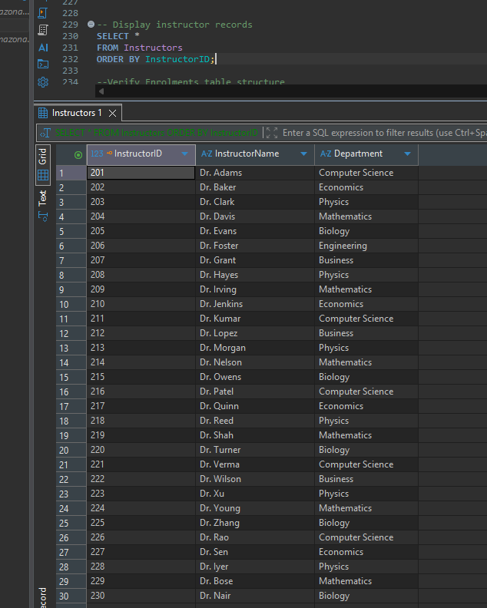
Q.5: Check existing enrolment records
-- Q.5: Check existing enrolment records
SELECT COUNT(*) AS TotalEnrolments
FROM Enrolments;
-- INSERT ENROLMENTS (301–310)
INSERT INTO Enrolments
(EnrollmentID, StudentID, CourseID, Semester, Grade)
VALUES
(301, 1, 101, 'Fall 2023', 'A'),
(302, 8, 101, 'Spring 2024', 'B'),
(303, 15, 101, 'Fall 2023', 'C'),
(304, 22, 101, 'Spring 2024', 'D'),
(305, 29, 101, 'Fall 2023', 'A'),
(306, 10, 102, 'Fall 2023', 'B'),
(307, 17, 102, 'Spring 2024', 'C'),
(308, 24, 102, 'Fall 2023', 'D'),
(309, 17, 103, 'Fall 2023', 'C'),
(310, 24, 103, 'Spring 2024', 'D');
-- Count the enrolment records
SELECT COUNT(*) AS TotalEnrolments
FROM Enrolments;
-- Display the inserted records
SELECT *
FROM Enrolments
ORDER BY EnrollmentID;
-- EnrollmentID 311–408 (98 records)
INSERT INTO Enrolments
(EnrollmentID, StudentID, CourseID, Semester, Grade)
VALUES
(311, 31, 103, 'Fall 2023', 'A'),
(312, 38, 103, 'Spring 2024', 'B'),
(313, 25, 104, 'Fall 2023', 'D'),
(314, 32, 104, 'Fall 2023', 'A'),
(315, 31, 105, 'Fall 2023', 'A'),
(316, 38, 105, 'Spring 2024', 'B'),
(317, 45, 105, 'Fall 2023', 'A'),
(318, 52, 105, 'Spring 2024', 'C'),
(319, 59, 105, 'Fall 2023', 'B'),
(320, 40, 106, 'Fall 2023', 'B'),
(321, 47, 106, 'Spring 2024', 'A'),
(322, 54, 106, 'Fall 2023', 'C'),
(323, 47, 107, 'Spring 2024', 'A'),
(324, 54, 107, 'Spring 2024', 'C'),
(325, 53, 108, 'Fall 2023', 'C'),
(326, 60, 108, 'Spring 2024', 'B'),
(327, 7, 108, 'Fall 2023', 'A'),
(328, 14, 108, 'Spring 2024', 'A'),
(329, 1, 109, 'Fall 2023', 'B'),
(330, 8, 109, 'Spring 2024', 'A'),
(331, 15, 109, 'Fall 2023', 'A'),
(332, 8, 110, 'Fall 2023', 'A'),
(333, 15, 110, 'Spring 2024', 'A'),
(334, 22, 110, 'Fall 2023', 'B'),
(335, 29, 110, 'Spring 2024', 'C'),
(336, 36, 110, 'Fall 2023', 'D'),
(337, 17, 111, 'Fall 2023', 'A'),
(338, 24, 111, 'Spring 2024', 'B'),
(339, 31, 111, 'Fall 2023', 'C'),
(340, 38, 111, 'Spring 2024', 'D'),
(341, 45, 111, 'Fall 2023', 'A'),
(342, 26, 112, 'Fall 2023', 'B'),
(343, 33, 112, 'Spring 2024', 'C'),
(344, 40, 112, 'Fall 2023', 'D'),
(345, 33, 113, 'Fall 2023', 'C'),
(346, 40, 113, 'Spring 2024', 'D'),
(347, 47, 113, 'Fall 2023', 'A'),
(348, 54, 113, 'Spring 2024', 'B'),
(349, 41, 114, 'Fall 2023', 'D'),
(350, 48, 114, 'Fall 2023', 'A'),
(351, 47, 115, 'Fall 2023', 'A'),
(352, 54, 115, 'Spring 2024', 'B'),
(353, 1, 115, 'Fall 2023', 'A'),
(354, 8, 115, 'Spring 2024', 'C'),
(355, 15, 115, 'Fall 2023', 'B'),
(356, 56, 116, 'Fall 2023', 'B'),
(357, 3, 116, 'Spring 2024', 'A'),
(358, 10, 116, 'Fall 2023', 'C'),
(359, 3, 117, 'Spring 2024', 'A'),
(360, 10, 117, 'Spring 2024', 'C'),
(361, 9, 118, 'Fall 2023', 'C'),
(362, 16, 118, 'Spring 2024', 'B'),
(363, 23, 118, 'Fall 2023', 'A'),
(364, 30, 118, 'Spring 2024', 'A'),
(365, 17, 119, 'Fall 2023', 'B'),
(366, 24, 119, 'Spring 2024', 'A'),
(367, 31, 119, 'Fall 2023', 'A'),
(368, 24, 120, 'Fall 2023', 'A'),
(369, 31, 120, 'Spring 2024', 'A'),
(370, 38, 120, 'Fall 2023', 'B'),
(371, 45, 120, 'Spring 2024', 'C'),
(372, 52, 120, 'Fall 2023', 'D'),
(373, 33, 121, 'Fall 2023', 'A'),
(374, 40, 121, 'Spring 2024', 'B'),
(375, 47, 121, 'Fall 2023', 'C'),
(376, 54, 121, 'Spring 2024', 'D'),
(377, 1, 121, 'Fall 2023', 'A'),
(378, 42, 122, 'Fall 2023', 'B'),
(379, 49, 122, 'Spring 2024', 'C'),
(380, 56, 122, 'Fall 2023', 'D'),
(381, 49, 123, 'Fall 2023', 'C'),
(382, 56, 123, 'Spring 2024', 'D'),
(383, 3, 123, 'Fall 2023', 'A'),
(384, 10, 123, 'Spring 2024', 'B'),
(385, 57, 124, 'Fall 2023', 'D'),
(386, 4, 124, 'Fall 2023', 'A'),
(387, 3, 125, 'Fall 2023', 'A'),
(388, 10, 125, 'Spring 2024', 'B'),
(389, 17, 125, 'Fall 2023', 'A'),
(390, 24, 125, 'Spring 2024', 'C'),
(391, 31, 125, 'Fall 2023', 'B'),
(392, 12, 126, 'Fall 2023', 'B'),
(393, 19, 126, 'Spring 2024', 'A'),
(394, 26, 126, 'Fall 2023', 'C'),
(395, 19, 127, 'Spring 2024', 'A'),
(396, 26, 127, 'Spring 2024', 'C'),
(397, 25, 128, 'Fall 2023', 'C'),
(398, 32, 128, 'Spring 2024', 'B'),
(399, 39, 128, 'Fall 2023', 'A'),
(400, 46, 128, 'Spring 2024', 'A'),
(401, 33, 129, 'Fall 2023', 'B'),
(402, 40, 129, 'Spring 2024', 'A'),
(403, 47, 129, 'Fall 2023', 'A'),
(404, 40, 130, 'Fall 2023', 'A'),
(405, 47, 130, 'Spring 2024', 'A'),
(406, 54, 130, 'Fall 2023', 'B'),
(407, 1, 130, 'Spring 2024', 'C'),
(408, 8, 130, 'Fall 2023', 'D');
-- Display all enrolments
SELECT *
FROM Enrolments
ORDER BY EnrollmentID;
-- Verify enrolment ID range and record count
SELECT
MIN(EnrollmentID) AS FirstEnrollment,
MAX(EnrollmentID) AS LastEnrollment,
COUNT(*) AS TotalEnrolments
FROM Enrolments;

SCREENSHOT D Enrolments 108 Records.png
Enrolments table verification
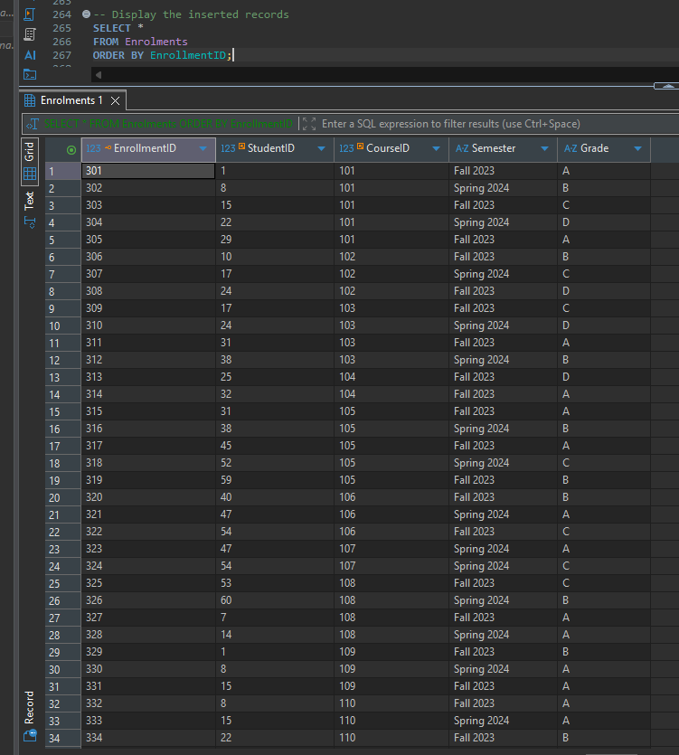
Q.6: CREATE THE CourseSummary VIEW
-- Q.6: CREATE THE CourseSummary VIEW
-- Purpose: Count students enrolled in each course
CREATE VIEW CourseSummary AS
SELECT
c.CourseID,
c.CourseName,
COUNT(e. StudentID) AS TotalStudents
FROM Courses AS c
LEFT JOIN Enrolments AS e
ON c.CourseID = e.CourseID
GROUP BY
c.CourseID,
c.CourseName;

-- B. Verify CourseSummary view
SELECT *
FROM CourseSummary
ORDER BY TotalStudents DESC, CourseID;
-- C. Check summary totals
SELECT
COUNT(*) AS TotalCourses,
SUM(TotalStudents) AS TotalEnrolments
FROM CourseSummary;

SCREENSHOT 01 | Step6_CourseSummary.png
Initial view: courses and student counts

SCREENSHOT 02 | Step6_CourseSummary_Verification.png
30 courses / 108 enrolments
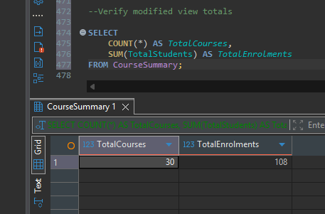

Q.7: CREATE InstructorSchedule VIEW
-- Q.7: CREATE InstructorSchedule VIEW
-- Purpose: Show instructors and courses
-- within their respective departments
CREATE VIEW InstructorSchedule AS
SELECT
i.InstructorID,
i.InstructorName,
i.Department,
c.CourseID,
c.CourseName
FROM Instructors AS i
LEFT JOIN Courses AS c
ON i.Department = c.Department;
-- STEP 7B: Display InstructorSchedule
SELECT *
FROM InstructorSchedule
ORDER BY InstructorID, CourseID;
-- Verify the total number of schedule rows
SELECT COUNT(*) AS TotalScheduleRows
FROM InstructorSchedule;

SCREENSHOT 03 | Step7_InstructorSchedule.png
Instructor-course view, including unmatched NULL
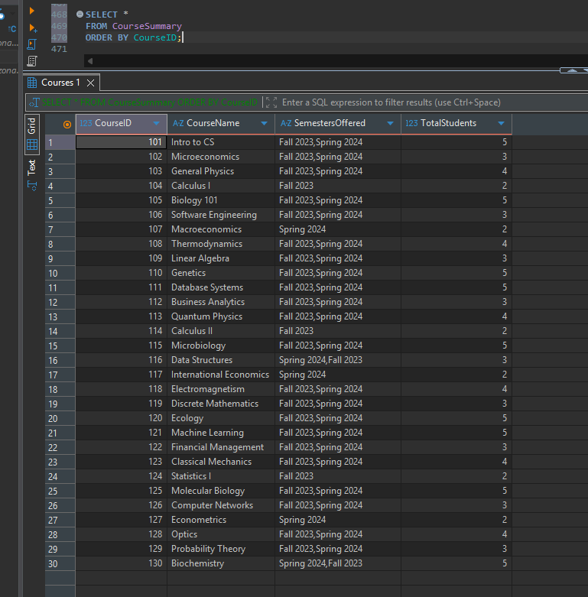

SCREENSHOT 04 | Step7_InstructorSchedule_Count.png
InstructorSchedule row count
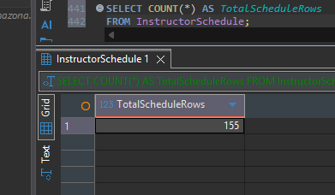
Q8.a: MODIFY CourseSummary VIEW
-- Q8.a: MODIFY CourseSummary VIEW
-- Add distinct semesters and total enrolments
-- Remove the previous view definition
DROP VIEW IF EXISTS CourseSummary;
-- Recreate the view with additional information
CREATE VIEW CourseSummary AS
SELECT
c.CourseID,
c.CourseName,
GROUP_CONCAT(DISTINCT e.Semester) AS SemestersOffered,
COUNT(e.StudentID) AS TotalStudents
FROM Courses AS c
LEFT JOIN Enrolments AS e
ON c.CourseID = e.CourseID
GROUP BY
c.CourseID,
c.CourseName;
--Display modified CourseSummary
SELECT *
FROM CourseSummary
ORDER BY CourseID;
--Verify modified view totals
SELECT
COUNT(*) AS TotalCourses,
SUM(TotalStudents) AS TotalEnrolments
FROM CourseSummary;

SCREENSHOT 05 Step8 Modified CourseSummary.png
Distinct semesters and enrolment counts
SCREENSHOT 06 Step8 CourseSummary Count.png
30 courses / 108 enrolments

Q.9: UPDATE InstructorSchedule VIEW
-- Q.9: UPDATE InstructorSchedule VIEW
-- Show courses offered in Spring 2024
-- Step 9: Remove the existing view
DROP VIEW IF EXISTS InstructorSchedule;
-- Step 9B: Recreate the view for Spring 2024
CREATE VIEW InstructorSchedule AS
SELECT
i.InstructorID,
i.InstructorName,
i.Department,
c.CourseID,
c.CourseName,
e.Semester
FROM Instructors AS i
INNER JOIN Courses AS c
ON i.Department = c.Department
INNER JOIN (
SELECT DISTINCT CourseID, Semester
FROM Enrolments
WHERE Semester = 'Spring 2024'
) AS e
ON c.CourseID = e.CourseID;
-- Display updated InstructorSchedule
SELECT *
FROM InstructorSchedule
ORDER BY InstructorID, CourseID;
-- Verify semester and schedule rows
SELECT
Semester,
COUNT(*) AS TotalScheduleRows
FROM InstructorSchedule
GROUP BY Semester;

SCREENSHOT 07 | Step9_Updated_InstructorSchedule.png
Spring 2024 schedule
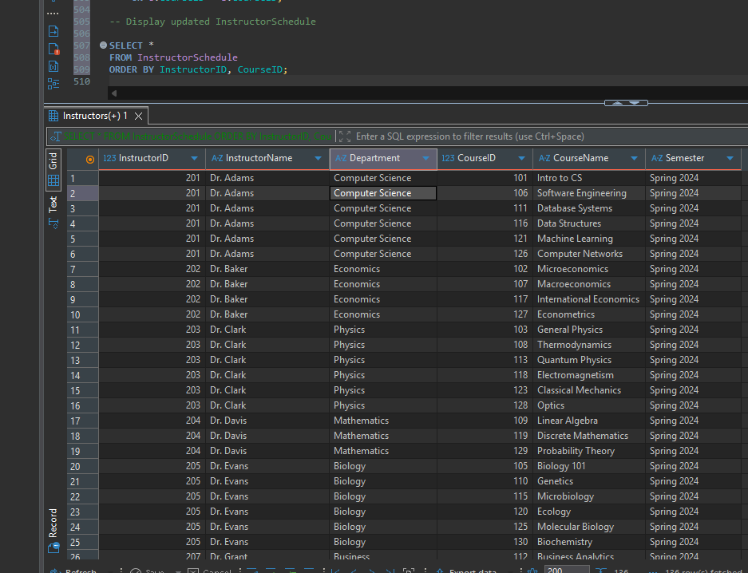
SCREENSHOT 08 | Step9_InstructorSchedule_Verification.png
136 Spring 2024 schedule rows
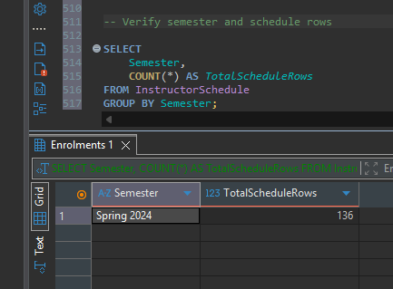

Q. 10: CREATE EligibleGraduates VIEW
-- Q. 10: CREATE EligibleGraduates VIEW
-- Students with GPA >= 3.7
CREATE VIEW EligibleGraduates AS
SELECT
StudentID,
FirstName,
LastName,
Major
FROM Students
WHERE GPA >= 3.7;
-- STEP 10B: Display eligible graduates
SELECT *
FROM EligibleGraduates
ORDER BY StudentID;
-- STEP 10C: Count eligible graduates
SELECT COUNT(*) AS TotalEligibleGraduates
FROM EligibleGraduates;

SCREENSHOT 09 | Step10_EligibleGraduates.png
Graduates listed before GPA added
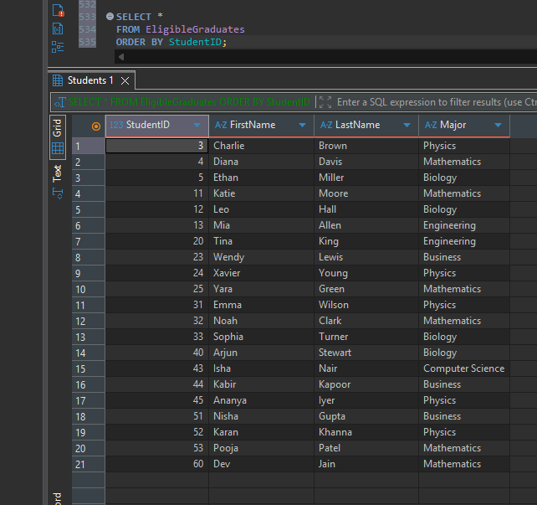

SCREENSHOT 10 | Step10_EligibleGraduates_Count.png
21 graduates
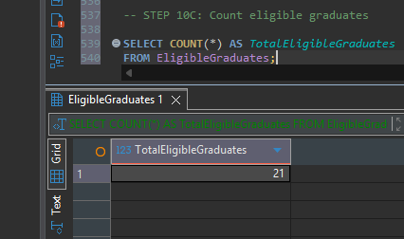
Q.11: ALTER EligibleGraduates VIEW
-- Q.11: ALTER EligibleGraduates VIEW
-- Add GPA to the displayed columns
-- Remove the existing view
DROP VIEW IF EXISTS EligibleGraduates;
-- Recreate the view including GPA
CREATE VIEW EligibleGraduates AS
SELECT
StudentID,
FirstName,
LastName,
Major,
GPA
FROM Students
WHERE GPA >= 3.7;
-- Display eligible graduates with their GPA
SELECT *
FROM EligibleGraduates
ORDER BY GPA DESC, StudentID;
-- Verify that all eligible students meet the GPA requirement
SELECT
COUNT(*) AS TotalEligibleGraduates,
MIN(GPA) AS LowestEligibleGPA,
MAX(GPA) AS HighestEligibleGPA
FROM EligibleGraduates;

SCREENSHOT 11 | Step11_EligibleGraduates_With_GPA.png
Graduates with GPA
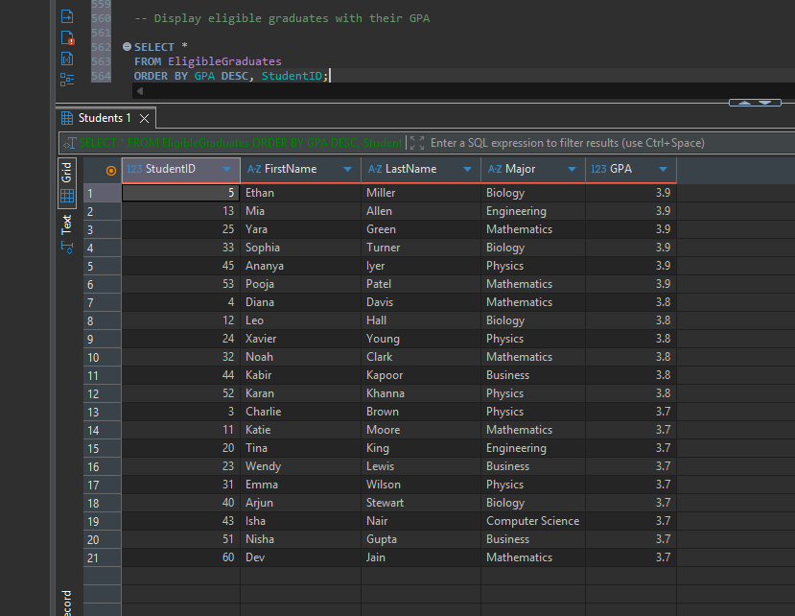
SCREENSHOT 12 | Step11_EligibleGraduates_Verification.png
21 graduates, GPA 3.7–3.9
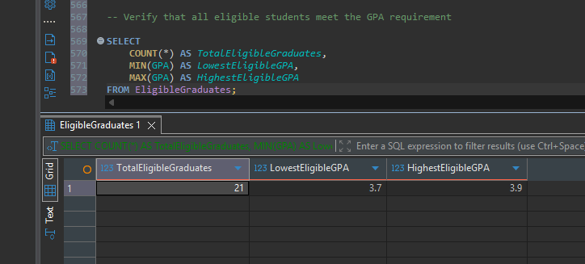

Q.12: RENAME CourseSummary VIEW
-- Q.12: RENAME CourseSummary VIEW
-- New name: CourseEnrolmentSummary
CREATE VIEW CourseEnrolmentSummary AS
SELECT
c.CourseID,
c.CourseName,
GROUP_CONCAT(DISTINCT e.Semester) AS SemestersOffered,
COUNT(e.StudentID) AS TotalStudents
FROM Courses AS c
LEFT JOIN Enrolments AS e
ON c.CourseID = e.CourseID
GROUP BY
c.CourseID,
c.CourseName;
-- Display the renamed view
SELECT *
FROM CourseEnrolmentSummary
ORDER BY CourseID;
-- Remove the old CourseSummary view
DROP VIEW IF EXISTS CourseSummary;
-- Verify the new view exists and the old one is removed
SELECT name
FROM sqlite_master
WHERE type = 'view'
ORDER BY name;

SCREENSHOT 13 | Step12_CourseEnrolmentSummary.png
New view results
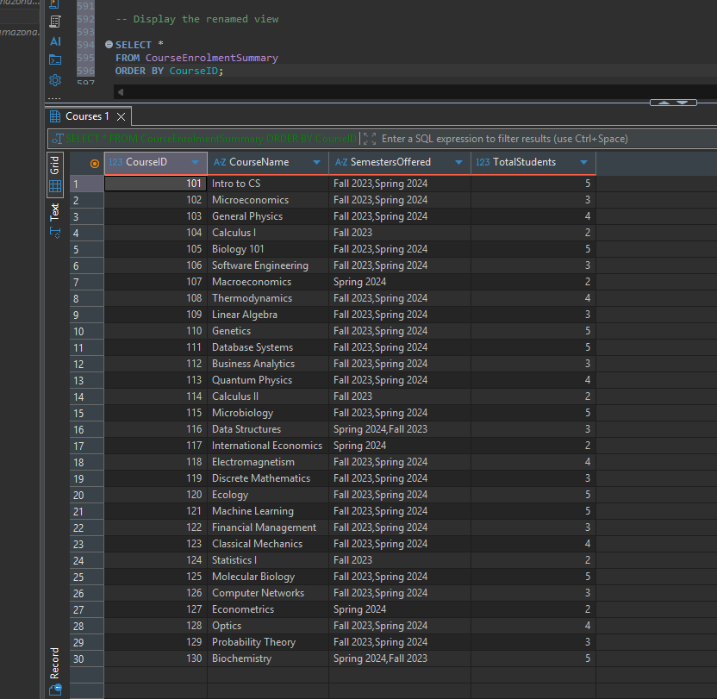
SCREENSHOT 14 | Step12_View_Rename_Verification.png
New view present, old view absent
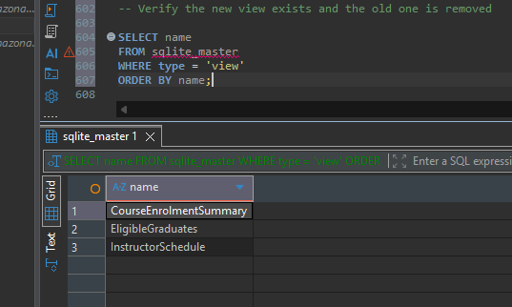

Q.13: DROP EligibleGraduates VIEW
-- Q.13: DROP EligibleGraduates VIEW
-- Purpose: Remove the view from the database
DROP VIEW IF EXISTS EligibleGraduates;
-- STEP 13B: Verify remaining views
SELECT name
FROM sqlite_master
WHERE type = 'view'
ORDER BY name;

SCREENSHOT 15 | Step13_Drop_EligibleGraduates.png
Two remaining views
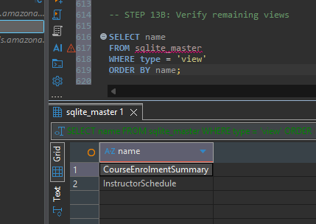
Q.14: CREATE SemesterCourses CTE
-- Q.14: CREATE SemesterCourses CTE
-- Purpose: List courses offered in Spring 2024
WITH SemesterCourses AS (
SELECT DISTINCT
c.CourseID,
c.CourseName,
c.Department,
e.Semester
FROM Courses AS c
INNER JOIN Enrolments AS e
ON c.CourseID = e.CourseID
WHERE e.Semester = 'Spring 2024'
)
SELECT *
FROM SemesterCourses
ORDER BY CourseID;
--VERIFY SemesterCourses CTE
-- Count courses offered in Spring 2024
WITH SemesterCourses AS (
SELECT DISTINCT
c.CourseID
FROM Courses AS c
INNER JOIN Enrolments AS e
ON c.CourseID = e.CourseID
WHERE e.Semester = 'Spring 2024'
)
SELECT COUNT(*) AS TotalSemesterCourses
FROM SemesterCourses;

SCREENSHOT 16 | Step14_SemesterCourses_CTE.png
27 Spring 2024 courses
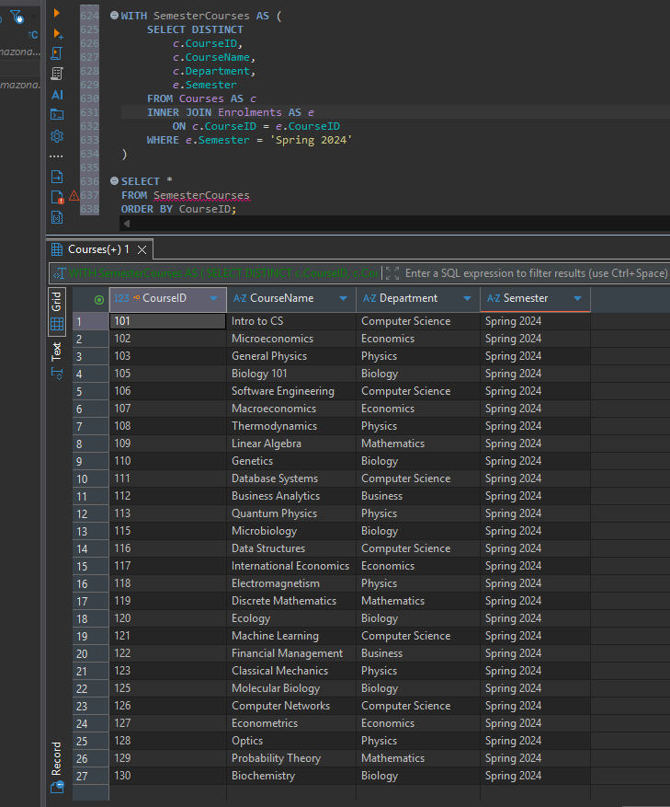
SCREENSHOT 17 | Step14_SemesterCourses_Count.png
Count of 27
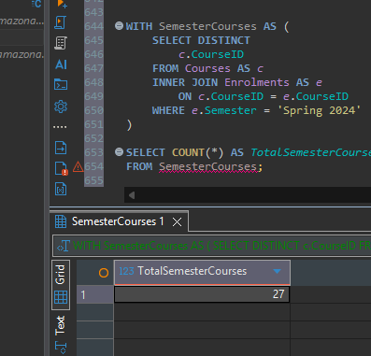
Technical notes
SQLite does not support ALTER VIEW or WITH CHECK OPTION. The script modifies and renames views by recreating their definitions. InstructorSchedule matches instructors to courses by department because the source tables do not include a direct instructor-course assignment relationship.
The SemesterCourses CTE uses Spring 2024 as the latest semester represented in the provided records, not the present calendar semester.
Conclusion
This exercise demonstrated relational table creation, record insertion, joins, aggregation, SQL view creation and modification, and common table expressions. The documented screenshots provide evidence of successful execution and verification.

